Conditional Statements
Name : Sreya Sudheeran
Mis : 612303175
Div : 2
Batch : S4

1. Write a C program to find maximum between two numbers.

#include <stdio.h>
int main() {
int num1, num2, max;
scanf("%d", &num1);/*inputs the two numbers*/
scanf("%d", &num2);
if (num1 > num2) { /*updates the max variable with the greater value among the two*/
max = num1;
}
else {
max = num2;
}
printf("%d\n", max);/*prints the maximum number*/
return 0;
}

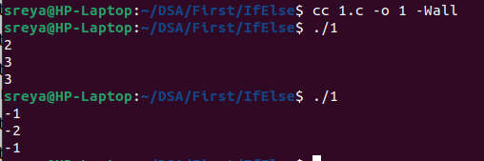
Output

2. Write a C program to check whether a number is negative, positive or zero.

#include <stdio.h>

int main() {
int num;
scanf("%d", &num);/*inputs the number*/
if (num > 0) { /*conditions to be checked*/
printf("positive.\n");
}
else if (num < 0) {
printf("negative.\n");
}
else {
printf("The number is zero.\n");
}
return 0;
}

Output

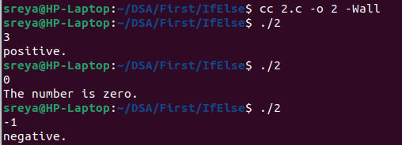

3. Write a C program to check whether a number is divisible by 5 and 11 or not.
#include <stdio.h>

int main() {
int num;
scanf("%d", &num); /*inputs number*/
if (num % 5 == 0 && num % 11 == 0) { /*checks if number is divisible or not */
printf("%d is divisible by both 5 and 11.\n", num);
}
else {
printf("%d is not divisible by both 5 and 11.\n", num);
}
return 0;
}
Output

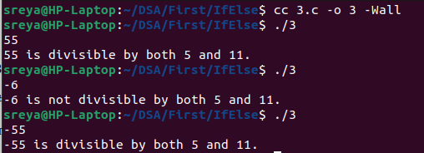

4. Write a C program to check whether a number is even or odd.
#include <stdio.h>

int main() {
int num;
scanf("%d", &num); /*inputs number*/
if (num % 2 == 0) { /*checks if odd or even */
printf("%d is even.\n", num);
}
else {
printf("%d is odd.\n", num);
}
return 0;
}
Output

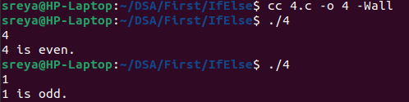

5. Write a C program to check whether a year is leap year or not.
#include <stdio.h>

int main() {
int year;
scanf("%d", &year); /*inputs the year*/
if ((year % 4 == 0 && year % 100 != 0) || year % 400 == 0) { /*Checks if the year is leap or not*/
printf("leap year\n");
}
else {
printf("not a leap year\n");
}
return 0;
}

Output
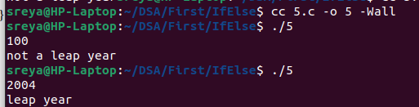

6. Write a C program to check whether a character is alphabet or not.
#include <stdio.h>
#include <ctype.h> /*to use isalpha */

int main() {
char ch;
scanf("%c", &ch);/*inputs the character*/
if (isalpha(ch)) { /*checks if it is a alphabet or not*/
printf("%c is an alphabet.\n", ch);
}
else {
printf("%c is not an alphabet.\n", ch);
}

return 0;
}
Output
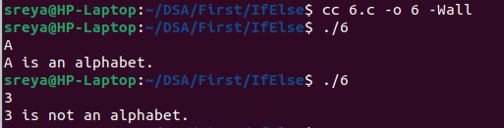

7. Write a C program to input any alphabet and check whether it is vowel or consonant.
#include <stdio.h>
#include <ctype.h> /*to use tolower */

int main() {
char ch;
int vowel;

scanf("%c", &ch); /*inputs the character*/

if (isalpha(ch)) { /*checks if it is a vowel or not*/
ch = tolower(ch);
vowel = (ch == 'a' || ch == 'e' || ch == 'i' || ch == 'o' || ch == 'u');
if (vowel) {
printf("%c is a vowel.\n", ch);
}
else {
printf("%c is a consonant.\n", ch);
}
}
else {
printf("%c is not an alphabet.\n", ch);
}

return 0;
}

Output

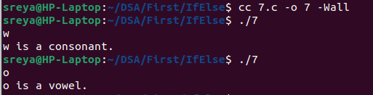

8. Write a C program to input any character and check whether it is alphabet, digit or special
character.
#include <stdio.h>
#include <ctype.h> /*to use isalpha */

int main() {
char ch;
scanf("%c", &ch); /*inputs the character*/
if (isalpha(ch)) {
printf("%c is an alphabet.\n", ch);
}
else if (isdigit(ch)) {
printf("%c is a digit.\n", ch);
}
else {
printf("%c is a special character.\n", ch);
}

return 0;
}
Output

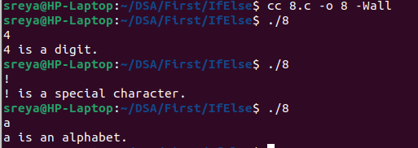

9. Write a C program to check whether a character is uppercase or lowercase alphabet.
#include <stdio.h>

int main() {
char ch;
scanf("%c", &ch);/*inputs the character*/
if (ch >= 'A' && ch <= 'Z') {
printf("%c is an uppercase alphabet.\n", ch);
}
else if (ch >= 'a' && ch <= 'z') {
printf("%c is a lowercase alphabet.\n", ch);
}
else {
printf("%c is not an alphabet.\n", ch);
}

return 0;
}

Output

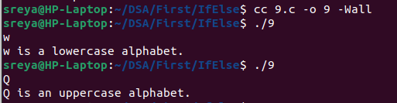

10. Write a C program to input month number and print number of days in that month.
#include <stdio.h>

int main() {
int month;
scanf("%d", &month);/*input the month number */
if (month < 1 || month > 12) {
printf("Please enter a number between 1 and 12.\n");
} else {
if (month == 1) {
printf("January has 31 days.\n");
}
else if (month == 2) {
printf("February has 28 or 29 days (leap year).\n");
}
else if (month == 3) {
printf("March has 31 days.\n");
}
else if (month == 4) {
printf("April has 30 days.\n");
}
else if (month == 5) {
printf("May has 31 days.\n");
}
else if (month == 6) {
printf("June has 30 days.\n");
}
else if (month == 7) {
printf("July has 31 days.\n");
}
else if (month == 8) {
printf("August has 31 days.\n");
}
else if (month == 9) {
printf("September has 30 days.\n");
}
else if (month == 10) {
printf("October has 31 days.\n");
}
else if (month == 11) {
printf("November has 30 days.\n");
}
else if (month == 12) {
printf("December has 31 days.\n");
}
}

return 0;
}

Output

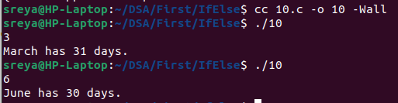

11. Write a C program to input angles of a triangle and check whether triangle is valid or not.
#include <stdio.h>

int main() {
float angle1, angle2, angle3;
scanf("%f", &angle1); /*input angles*/
scanf("%f", &angle2);
scanf("%f", &angle3);
if (angle1 + angle2 + angle3 == 180.0) {
printf("The angles form a valid triangle.\n");
}
else {
printf("The angles do not form a valid triangle.\n");
}

return 0;
}
Output

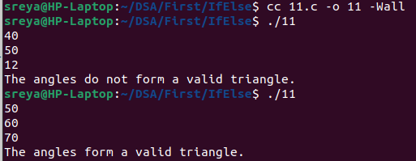

12. Write a C program to check whether the triangle is equilateral, isosceles or scalene triangle.
#include <stdio.h>
int main() {
float side1, side2, side3;
scanf("%f", &side1);/*inputs the sides of triangles*/
scanf("%f", &side2);
scanf("%f", &side3);
if (side1 == side2 && side2 == side3) {
printf("Triangle is an equilateral triangle.\n");
}
else if (side1 == side2 || side1 == side3 || side2 == side3) {
printf("Triangle is an isosceles triangle.\n");
}
else {
printf("Triangle is a scalene triangle.\n");
}
return 0;
}
Output

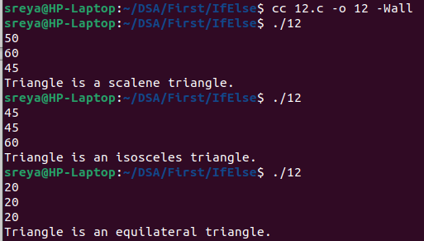

13. Write a C program to find all roots of a quadratic equation.
#include <stdio.h>
#include <math.h> /*to use sqrt*/

int main() {
float a, b, c;
float discriminant, root1, root2, realPart, imaginaryPart;
scanf("%f", &a); /*inputs the coefficients*/
scanf("%f", &b);
scanf("%f", &c);
discriminant = b*b - 4*a*c; /*calculates the discriminant*/
if (discriminant > 0) {
root1 = (-b + sqrt(discriminant)) / (2*a);
root2 = (-b - sqrt(discriminant)) / (2*a);
printf("%.2f\n", root1);
printf("%.2f\n", root2);
}
else if (discriminant == 0) {
root1 = -b / (2*a);
printf("%.2f\n", root1);
printf("%.2f\n", root1);
}
else {
realPart = -b / (2*a);
imaginaryPart = sqrt(-discriminant) / (2*a);
printf("%.2f + %.2fi\n", realPart, imaginaryPart);
printf("%.2f - %.2fi\n", realPart, imaginaryPart);
}

return 0;
}
Output

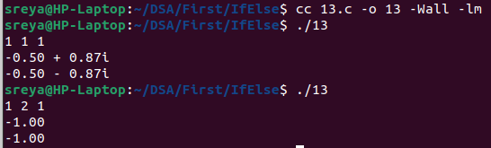

14. Write a C program to input marks of five subjects Physics, Chemistry, Biology,
Mathematics and Computer. Calculate percentage and grade according to following:
Percentage >= 90% : Grade A
Percentage >= 80% : Grade B
Percentage >= 70% : Grade C
Percentage >= 60% : Grade D
Percentage >= 40% : Grade E
Percentage < 40% : Grade F
#include <stdio.h>

int main() {
float physics, chemistry, biology, mathematics, computer;
float total_marks, percentage;
char grade;
scanf("%f", &physics);/*inputs the marks of subjects*/
scanf("%f", &chemistry);
scanf("%f", &biology);
scanf("%f", &mathematics);
scanf("%f", &computer);
total_marks = physics + chemistry + biology + mathematics + computer;
percentage = (total_marks / 500.0) * 100.0;/*calculates percentage*/
if (percentage >= 90.0) {
grade = 'A';
}
else if (percentage >= 80.0) {
grade = 'B';
}
else if (percentage >= 70.0) {
grade = 'C';
}
else if (percentage >= 60.0) {
grade = 'D';
}
else if (percentage >= 40.0) {
grade = 'E';
}
else {
grade = 'F';
}
printf("Percentage : %.2f%%\n", percentage);
printf("Grade : %c\n", grade);

return 0;
}
Output

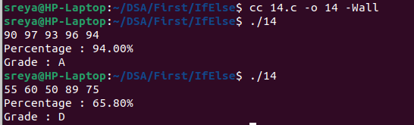

15. Write a C program to input basic salary of an employee and calculate its Gross salary
according to following:
Basic Salary <= 10000 : HRA = 20%, DA = 80%
Basic Salary <= 20000 : HRA = 25%, DA = 90%
Basic Salary > 20000 : HRA = 30%, DA = 95%
#include <stdio.h>

int main() {
float basicSalary, grossSalary;
float hra, da;
scanf("%f", &basicSalary);/*inputs the basic salary*/
if (basicSalary <= 10000) {
hra = 0.2 * basicSalary;
da = 0.8 * basicSalary;
}
else if (basicSalary <= 20000) {
hra = 0.25 * basicSalary;
da = 0.9 * basicSalary;
}
else {
hra = 0.3 * basicSalary;
da = 0.95 * basicSalary;
}
grossSalary = basicSalary + hra + da;
printf("Basic Salary: %.2f\n", basicSalary);
printf("HRA: %.2f\n", hra);
printf("DA: %.2f\n", da);
printf("Gross Salary: %.2f\n", grossSalary);

return 0;
}

Output

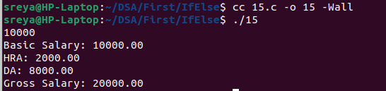

16. Write a C program to input electricity unit charges and calculate total electricity bill
according to the given condition:
For first 50 units Rs. 0.50/unit
For next 100 units Rs. 0.75/unit
For next 100 units Rs. 1.20/unit
For unit above 250 Rs. 1.50/unit
An additional surcharge of 20% is added to the bill
#include <stdio.h>

int main() {
int units;
float total, surcharge = 0.20;
float rate1 = 0.50, rate2 = 0.75, rate3 = 1.20, rate4 = 1.50;
scanf("%d", &units); /*inputs the units used*/
if (units <= 50) {
total = units * rate1;
}
else if (units <= 150) {
total = 50 * rate1 + (units - 50) * rate2;
}
else if (units <= 250) {
total = 50 * rate1 + 100 * rate2 + (units - 150) * rate3;
}
else {
total = 50 * rate1 + 100 * rate2 + 100 * rate3 + (units - 250) * rate4;
}
total += surcharge * total;
printf("Total electricity bill = Rs. %.2f\n", total);

return 0;
}
Output

